Created By : Yog Batra
https://www.linkedin.com/in/yog-batra-661798179/

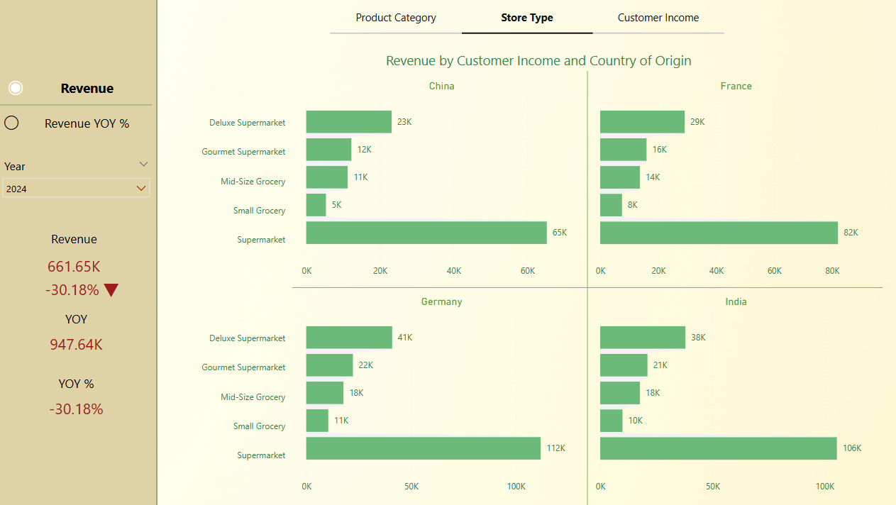

📊 Interactive Revenue Intelligence Dashboard (Fun with Fictional Stats)

✅ Project Summary
Built in Power BI as a personal side project, this dashboard explores revenue performance across four countries — China, France, Germany, and India — with the ability to toggle between Store Type, Product Category, and Customer Income Group.
What makes it fun?
👉 All the data is entirely made up. So the insights are as entertaining as they are “informative.”
🔄 Key Features
- Dynamic parameter control to switch views by store type, income, or product.
- A metric toggle to view either:
  - Total Revenue
  - Year-over-Year Growth Rate
- Sleek visual layout with horizontal bar charts for easy cross-country comparisons.
- Built using Power BI’s DAX, slicers, and clean UX design principles.

🤯 Fun “Insights” That Aren’t Real
- Germany’s supermarkets dominate, selling more than France and China combined.
- France’s high-income customers love their gourmet supermarkets — .
- A -30.18% YoY decline sounds alarming, but don’t worry — the economy of this imaginary world is resilient.

🌱 What I Learned (Besides How to Make Up Stats)
- Built parameter-based visuals to switch dimensions on the fly.
- Practiced advanced DAX measures and interactive UX in Power BI.
- Learned that designing a dashboard is as much about storytelling as it is about data.
- Had fun using fake numbers to create a dashboard that feels real.
TAKEAWAY : EVEN THOUGH THE DATA IS FAKE, THE CHALLENGES WERE REAL

